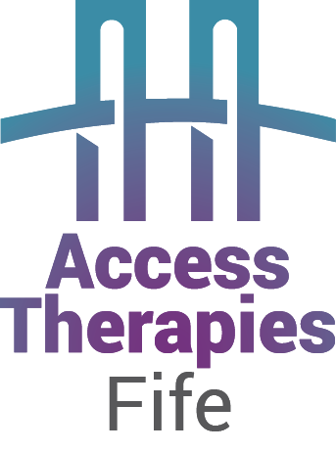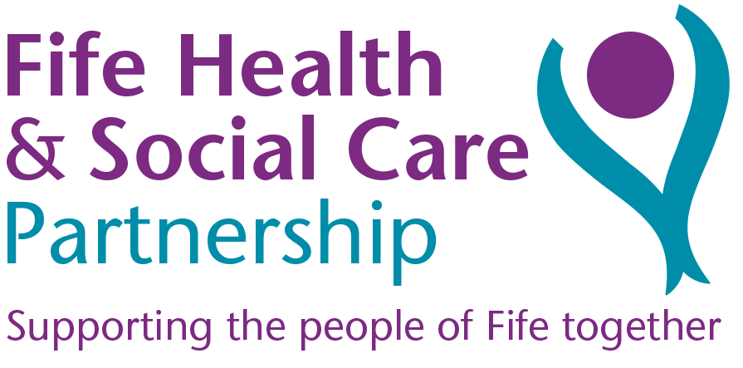

**Date: ………………………..**

**I am recommending the following:** (Please tick)

Access Therapies Fife website Self help resources

and Self help guides www.accesstherapiesfife.scot.nhs.uk

**Psychology Enhanced Engagement Team**

**The Psychology Enhanced Engagement Team (PEET), (formerly known as Guided Self Help Service) provides a range of brief interventions for people with psychological difficulties, such as low mood, anxiety, panic, worry, sleep difficulties or stress**

**Services provided are-:**

* Back on Track
* Anger Management
* Decider skills (referral to group or individual sessions)
* Silvercloud
* Individual PEET Intervention

Please book via the Access Therapies Fife Website

[Home - Access Therapies Fife NHS (scot.nhs.uk)](https://www.accesstherapiesfife.scot.nhs.uk/)

**Assertiveness**

* 1 class which lasts about an hour and a half where you will learn to understand different communication styles, learning what it means to be assertive and the difference between passive, assertive and aggressive.
* Courses running all throughout the year across Fife
* This is a lecture style course delivered by our team through presentations.  It is not group therapy.
* You can take along a friend or family member for support

Please book via the Access Therapies Fife Website

[Home - Access Therapies Fife NHS (scot.nhs.uk)](https://www.accesstherapiesfife.scot.nhs.uk/)

**Sleep Well**

* 1 class which lasts 2 hours where you can learn core concepts of good sleep habits and strategies to improve sleep.
* Courses running all throughout the year across Fife
* This is a lecture style course delivered by our team through presentations.  It is not group therapy.
* You can take along a friend or family member for support

Please book via the Access Therapies Fife Website

[Home - Access Therapies Fife NHS (scot.nhs.uk)](https://www.accesstherapiesfife.scot.nhs.uk/)

**Step on Stress**

* 3 sessions over 3 weeks (1.5 hours each session) where you can learn how to reduce stress, anxiety and panic as well as boost your self esteem
* Courses running all throughout the year across Fife
* This is a lecture style course delivered by our team through presentations.  It is not group therapy.
* You can take along a friend or family member for support

Please book via the Access Therapies Fife Website

[Home - Access Therapies Fife NHS (scot.nhs.uk)](https://www.accesstherapiesfife.scot.nhs.uk/)

**Moodcafe website -** [**www.moodcafe.co.uk**](http://www.moodcafe.co.uk)

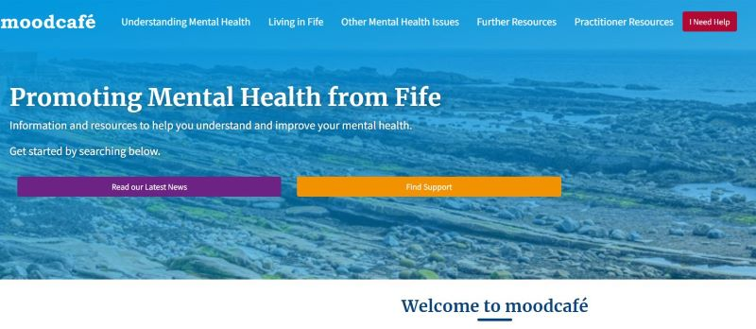

**Resources for:**

* Parents
* Children and Parents
* Carers
* People with learning disabilities
* For Older people

**Information and resources about**: Anger, Addictions, Bereavement, Bullying & harassment, Eating Disorders, Extreme moods and bipolar disorder, Memory problems, Pregnancy and postnatal emotional problems, Self esteem, Self harm, Trauma and abuse

[](http://www.moodcafe.co.uk/) Well-being and Lifestyle [](http://www.moodcafe.co.uk/)Advice; Advice about coping with physical health problems; Advice about managing feelings plus information about CBT tools

[](http://www.moodcafe.co.uk/)