
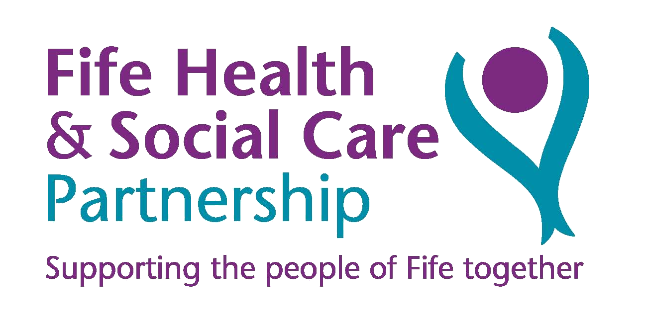
SilverCloud Referrer Information Sheet
Hopefully you will be familiar with Beating the Blues, the online CBT package for people with mood and anxiety difficulties. We are delighted to let you know that you now have access to a further 8 online CBT packages for the following presentations:
- Space from COVID-19
- Space from Health Anxiety
- Space from Social Anxiety
- Space in Chronic Pain from Depression and Anxiety
- Space in Lung Conditions from Depression and Anxiety
- Space in Rheumatoid Arthritis from Depression
- Space in Diabetes from low Mood and Anxiety
- Space in Coronary Heart Disease from Depression and Anxiety
- Space from Panic
- Space from OCD
- Space from Phobia
- Space for perinatal Wellbeing

It is suitable for patients whether being treated with or without medication, and for those who have co morbid long term health conditions. It is suitable for patients aged 18 and above.

Suitable for patients with:
- Mild to moderate depression and/or anxiety: including phobias and panic attacks
- Willingness to be pro-active in their treatment recovery and to use a computer programme
Not suitable for patients:
- With active suicidal ideas or plans: refer to Unscheduled Care Team
- Who are unable to read or write English (reading age below 10/11 years)
- In acute phase of psychosis or mania, or with cognitive functioning disorder, e.g. dementia

Referral Procedure:
Via SCI Gateway – Fife > Fife Non-GP Locations/Providers > Lynebank Hospital > SilverCloud
Completing Standard Referral form email to fife.psychologysilvercloud@nhs.scot
Completing Standard Referral form and post via internal mail (cCBT Administrators, Psychology Department, Lynebank Hospital)

Where can patients complete the course
Your patient will need a PC, laptop, smart phone or tablet, with either speakers or earphones. If your patient does not have access to these they can complete the programme at one of our community sites such as the library.

How do patients access the program
To access the programme the patient will be sent an invitation email , which will be provided by the Fife SilverCloud co-ordinator after a referral is received.

Suicide Alert

At the beginning of each module risk alerts can be triggered during the completion of questionnaires that asks questions around self harm/suicidal ideation. The standard risk setting is triggered if users score 1 or more on Q9 of the PHQ9. The user is immediately presented with crisis/help information. Subsequently, users are asked about, plans, intention, likelihood on acting on thoughts and protective factors. If a user responds with “YES” to having plans or intentions, or scores more than 3 on the likelihood scale, a risk email is sent to the supporter/admin inbox.

Space from COVID-19
This package helps to normalise worries and emotions, provides coping strategies and gives practical solutions for maintaining wellbeing in a time of crisis. So this is suitable for anyone who is struggling specifically in relation to COVID-19.

Space from Health Anxiety
This package is suitable for people with mild to moderate anxiety about becoming ill (e.g. excessive reassurance seeking, excessive focus on possible or perceived symptoms, excessive researching of illnesses, etc.). This package is not suitable for people who have anxiety about a physical illness they do actually have, nor those where a physical illness diagnosis is still being assessed.

Space from Social Anxiety
This package is suitable for people with mild to moderate anxiety in relation to social situations.

Space in Chronic Pain from Depression and Anxiety
This is suitable for individuals with mild to moderate symptoms of depression and anxiety who are living with chronic pain. This is not suitable for people still undergoing investigations for their pain or those experiencing chronic pain in relation to a serious illness. The programme aims to relieve symptoms of depression and anxiety through cCBT. This programme is NOT suitable for individuals who need specific, targeted input to address self-management of their chronic pain.
Space in Lung Conditions from Depression and Anxiety
This is suitable for individuals with mild to moderate symptoms of depression and anxiety who are living with a formal diagnosis of a long-term lung condition. This is not suitable for individuals undertaking treatment for cancer and/or receiving end-of-life care. The programme aims to relieve symptoms of depression and anxiety through cCBT. This programme is NOT suitable for individuals who need specific, targeted input to address self-management of their lung condition.

Space in Rheumatoid Arthritis from Depression
This is suitable for individuals with mild to moderate symptoms of depression who are living with a formal diagnosis of Rheumatoid Arthritis. The programme aims to relieve symptoms of depression through cCBT. This programme is NOT suitable for individuals who need specific, targeted input to address self-management of their rheumatoid arthritis.

Space in Diabetes from Low Mood and Anxiety
This is suitable for individuals with mild to moderate symptoms of anxiety and/or low mood who are living with a formal diagnosis of type 1 or type 2 diabetes. This programme is recommended for people with diabetes where psycho-social circumstances are the primary maintaining factors in their mental health difficulties. This programme is NOT suitable for people with diabetes who need specific, targeted input to address their diabetes self-care (i.e. non-adherence to a recommended medical regime characterised by insufficient/excessive blood glucose monitoring, avoiding insulin administration, or engaging in disordered eating behaviours).

Space in Chronic Heart Disease from Depression and Anxiety
This is suitable for individuals with mild to moderate symptoms of depression and anxiety who are living with a formal diagnosis of coronary heart disease (CHD). The programme aims to relieve symptoms of depression and anxiety through cCBT. This programme is NOT suitable for individuals who need specific, targeted input to address self-management of their CHD.

Space from Panic
This programme helps you to learn the skills to tackle the symptoms at the heart of your panic; a fear of losing control, or that something very bad may happen or is happening, and persistent fear about future panic attacks. Effective techniques such as gradual exposure help you to face your fears and cope with anxiety, rather than fighting against it.

Space from OCD
This has been designed to relieve the symptoms of OCD by focusing on developing more flexible ways of thinking. Increasing the awareness of emotions and understanding of obsessions and compulsions and their role in maintaining anxiety. Additionally the programme uses exposure response prevention techniques to learn to cope with anxiety provoking situations without engaging in compulsions.

Space from Phobia
This programme is designed to help you to relieve the symptoms of phobia and help you to face and manage the overwhelming fear caused by a situation or object. You can:
- Learn effective techniques to look at anxiety provoking situations in new, less frightening ways.
- Develop better coping skills.

Space for Perinatal Wellbeing
The perinatal programme has been designed to relieve subthreshold symptoms of worry and low mood in the perinatal period, as well as helping with sleep difficulties, it enables the client to identify If further support is required for an anxiety disorder or clinical depression.

