### What happens to CMHT referrals?

The CMHT meets weekly. Part of the meeting is used for triaging referrals to the Team. Members of the CMHT discuss each referral and decide which profession/department will see the person first. This could include:

* Community Psychiatric Nursing
* Psychology
* Psychiatry
* Occupational Therapy
* Day Hospital
* West Fife Community Outreach Team

Following the CMHT meeting, the patient will receive contact from the profession/department that they have been triaged to.

The GP (and referrer if not GP) will also be sent a letter advising them of the outcome.

If additional information is needed to triage the referral, a one off assessment and triage appointment may be carried out by a team member. Any additional information will be brought back to the next CMHT meeting.

**All referrals to CMHTs should be made via SCI gateway and with GP knowledge**

### Who may benefit most from being referred to a CMHT?

People with complex mental health needs where there are concerns regarding impairment as a consequence of mental illness and/or psychiatric disorder

Where input from several mental health professionals is required (e.g. Psychiatrist, Occupational Therapist, Psychologist, Community Psychiatric Nurse)

Where there is diagnostic uncertainty and where a diagnosis is likely to influence treatment

Where there are concerns about risk

Where other treatments have been ineffective such as primary care based psychological approaches or medication (as per NHS Fife ADTC guidelines)

**Which patient groups would be better supported by other services?**

For people with less severe and less complex mental health problems consider options such as:

* Self Help (e.g. Book Prescribing; Moodcafe, Online CBT - SilverCloud
* Self referral courses (e.g. Step on Stress)
* “Living Life” - NHS Telephone CBT service
* Voluntary Counselling Services (e.g. CRUSE Bereavement, Talk Matters, Safe Space, Kingdom Abuse Survivors Project, Relationships Scotland)
* Practice Counselling Services
* Primary Care Psychology

People whose primary problem is substance misuse (consider referral to Addiction Services; ADAPT Drop in service; Fife Alcohol Service (FASS); DAPL; FIRST)

People whose psychological and emotional difficulties are as a result of physical health problems (consider referral to Clinical Health Psychology)

People with a diagnosed Learning Disability (consider referral to Learning Disability services)

People out-with the 18-65 age range (<18 consider referral to Child and Adolescent services; >65 consider referral to Older Adults services)

### What kind of information would it be helpful to include in your referral letter?

1. Outline of mental health/psychological problems and reason for referral
2. Relevant background (e.g. known abuse/trauma history, domestic violence, family psychiatric history, information about previous input from mental health professionals)
3. Impression of risk factors should be included in referrals from GPs. Other disciplines that routinely use a Risk Assessment form should include this when referring
4. Physical Health (include any significant problems that may impact on mental health)
5. Previous treatments / medical input and efficacy (Note: Have any medications prescribed had an adequate trial? Please refer to Fife Joint Formulary guidelines)
6. Patient’s awareness of / consent to CMHT referral

**Contact details**

Gill McNeil

Kirkcaldy CMHT administrator

Westfiield Corridor

Whytemans Brae

01592643355 ext 23942

If urgent contact is required but it is not an emergency, please contact the CMHT on

01592643355 ext 23942/22031/22061

If you, or anyone you know, requires this information in large print, audio or Braille contact the Fife Healthline on 0845 7626799 – or in another language, contact the Patient Records Manager, Victoria Hospital, Kirkcaldy 01592 643355.

**Urgent referrals:**

Please phone the CMHT for advice about potential urgent referrals, especially if there is uncertainty about this

The decision to accept a referral as “urgent” will be made by the CMHT

Referrers will be notified if priority changes

Referrals accepted as “urgent” will usually be seen within 7 days, commonly sooner

For patients that need to be seen the same day:

If the case is open to the CMHT already, please contact them directly.

If the case is not open to the CMHT, please contact the Unscheduled Care Assessment Team. Telephone number: 01592 643355 Ext. 23999

**Suggestions for management of “urgent” cases until seen by CMHT**

* Planned review appointment with the patient
* Contact CMHT if priority changes or there are significant clinical issues that require an update
* Use of Unscheduled Care Assessment Team if emergency contact is required

**Community Mental Health Teams in Central Fife**

Referral Guidance

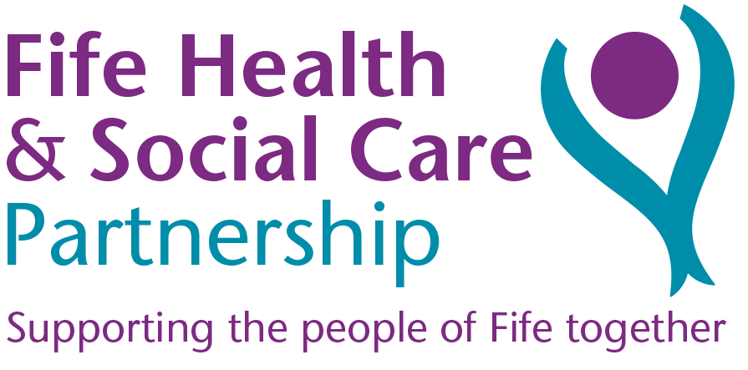



**Information for General Practitioners, Primary Care Allied Health Professionals and other Health & Social Care Partners**