Who may benefit most from CMHT referral?
- People with complex mental health needs where there are concerns regarding impairment as a consequence of mental illness and/or disorder
- Where input from several mental health professionals is required (e.g. Psychiatrist, Occupational Therapist, Psychologist, Community Psychiatric Nurse)
- Where there is diagnostic uncertainty and where a diagnosis is likely to influence treatment
- Where there are concerns about risk
- Where other treatments have been ineffective such as primary care based psychological approaches or medication (as per NHS Fife ADTC guidelines)

All referrals to CMHT should be made via SCI gateway and with GP knowledge

Which patient groups would be better supported by other services?
- People with less severe and less complex mental health problems. Consider options such as:
- Self Help (e.g. Book Prescribing; Moodcafé, online CBT – SilverCloud.
- Self referral courses (e.g. Step on Stress)
- “Living Life”: NHS Telephone CBT service
- Voluntary Counselling Services (e.g. CRUSE Bereavement, Talk Matters, Safe Space, Kingdom Abuse Survivors Project, Relationships Scotland)
- Practice Counselling Services
- Primary Care Psychology
- People whose primary problem is substance misuse
- Refer to: Addiction Services; ADAPT Drop in service; Fife Alcohol Service (FASS); DAPL; FIRST
- People whose psychological and emotional difficulties are as a result of physical health problems.
- Refer to Clinical Health Psychology

- People with a diagnosed Learning Disability
- Refer to Learning Disability services.
- People out with the 18-65 age range
- <18 refer to Child and Adolescent services;
- >65 refer to Older Adults services)

What to include in your referral?
- Outline of mental health/psychological problems and reason for referral
- Relevant background (e.g. known abuse/trauma history, domestic violence, family psychiatric history, details of previous input from mental health professionals)
- Impression of risk factors: To be included in all referrals from GPs, and referrals from other disciplines which routinely use a Risk Assessment form
- Physical Health (include any significant problems that may impact on mental health)
- Previous treatments / medical input and efficacy (Note: Have any medications prescribed had an adequate trial? Please refer to Fife Joint Formulary guidelines)
- Patient’s awareness of / consent to CMHT referral, and expectations from the service

What happens to CMHT referrals?
Referrals are triaged weekly CMHT meeting. Each referral is discussed and the team decides which profession/department will see the person first. This could include:
- Community Psychiatric Nursing
- Psychology
- Psychiatry
- Occupational Therapy
- Day Hospital

Following the CMHT meeting, the patient will receive contact from the profession/department that they have been triaged to.

The GP (and referrer if not GP) will also be sent a letter advising them of the outcome.

If additional information is needed to triage the referral, a one off assessment and triage appointment may be carried out by a team member. Any additional information will be brought back to the next CMHT meeting.

Urgent referrals:
Please phone the CMHT for advice about potentially urgent referrals, especially if there is uncertainty about this.
- The decision to accept a referral as “urgent” will be made by the CMHT
- Referrers will be notified if priority changes
- Referrals accepted as “urgent” will usually be seen within 7 days, commonly sooner.
For patients who need to be seen the same day:
- If the case is open to the CMHT already, please contact them directly.
- If the case is not open to the CMHT, please contact the Unscheduled Care Assessment Team. Telephone number: 01592 643355 Ext. 23999

Suggestions for management of “urgent” cases until seen by CMHT
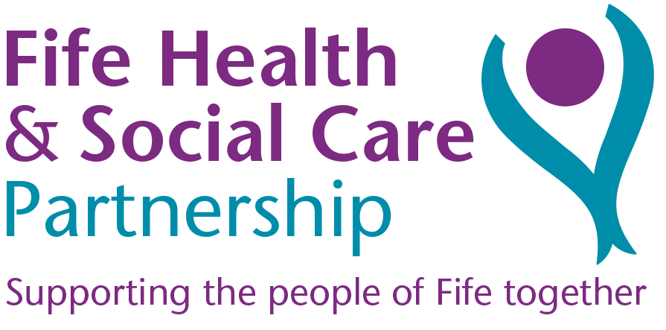
- Planned review appointment with the patient
- Contact CMHT if priority changes or there are significant clinical issues that require an update
- Use of Unscheduled Care Assessment Team if emergency assessment is required

contact Us

CMHT Secretary
Phase 1, Queen Margaret Hospital, Whitefield Road, Dunfermline KY12 OSU
Tel: 01383 623623 Ext: 24058

Referral Guidance
Community Mental Health Teams

Information for General Practitioners, Primary Care Allied Health Professionals and other Health & Social Care Partners

