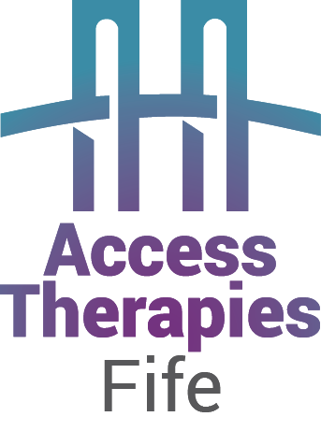
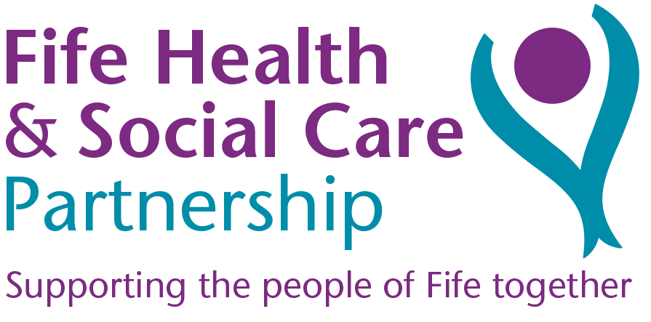

Date: ………………………..
I am recommending the following: (Please tick)

Access Therapies Fife website Self help resources
and Self help guides www.accesstherapiesfife.scot.nhs.uk

Step on Stress
- 3 sessions over 3 weeks (1.5 hours each session) where you can learn how to reduce stress, anxiety and panic as well as boost your self esteem
- Courses running all throughout the year across Fife
- This is a lecture style course delivered by our team through presentations. It is not group therapy.
- You can take along a friend or family member for support
Please book via the Access Therapies Fife Website
Home - Access Therapies Fife NHS (scot.nhs.uk)

Back on Track
- Therapist-guided self-help course which provides ways to improve mood and manage symptoms of depression
- Blend of online videos, teaching core concepts, workbook and up to four brief video/phone appointments with a therapist.
Please book via the Access Therapies Fife Website
Home - Access Therapies Fife NHS (scot.nhs.uk)

Change Up
- 10 session therapy group to help people with a range of emotional problems, such as anxiety, depression, obsessive-compulsive disorder, panic and social anxiety
- Groups run throughout the year in venues across Fife
- This is a therapy group and is run by NHS Psychologists
For a pre-group assessment – please book via the Access Therapies Fife Website. Home - Access Therapies Fife NHS (scot.nhs.uk)
They will then contact you to arrange a pre-group assessment appointment with one of our therapists
If your pre-group assessment appointment is by telephone, please make sure you take the call in a confidential place and that we have your correct telephone number. We shall call you twice, once at the agreed appointment time, and again 5 minutes later. If there is no answer we shall assume that you no longer want therapy and shall refer you back to your GP.

Moodcafe website - www.moodcafe.co.uk

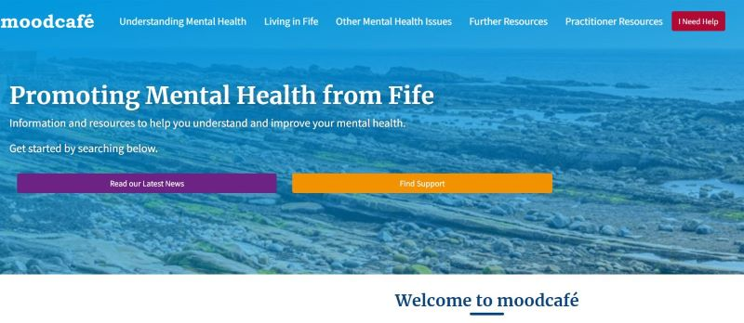

Resources for:
- Parents
- Children and Parents
- Carers
- People with learning disabilities
- For Older people

Information and resources about: Anger, Addictions, Bereavement, Bullying & harassment, Eating Disorders, Extreme moods and bipolar disorder, Memory problems, Pregnancy and postnatal emotional problems, Self esteem, Self harm, Trauma and abuse

Well-being and Lifestyle Advice; Advice about coping with physical health problems; Advice about managing feelings plus information about CBT tools

