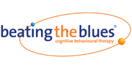
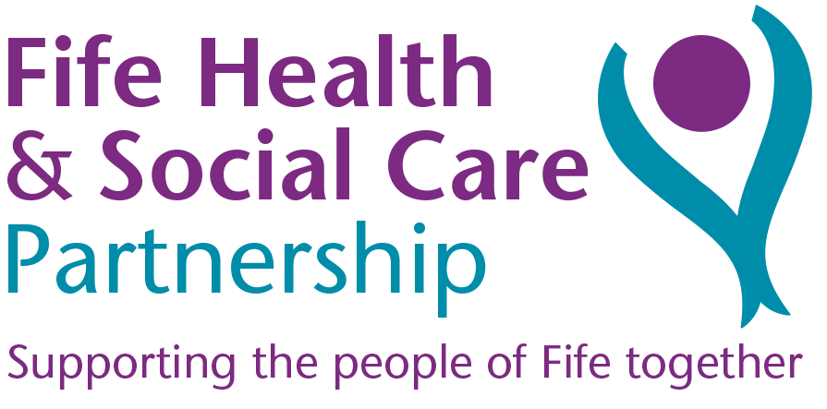
Patient Information Sheet

What is Beating the Blues
Beating the Blues is an online treatment programme that uses cognitive behavioural therapy (CBT) to help people experiencing depression and/or anxiety.

What is CBT
CBT is a psychological therapy that works on the relationships between thoughts (cognitions), behaviours and feelings. CBT teaches the individual how to recognise and tackle problems here and now, rather than in the past. It has been widely studied and has been proven to work especially on depression and anxiety.

What does Beating the Blues consist of
Beating the Blues consists of eight, one hour sessions completed weekly. The programme is interactive, during session you can watch video clips, complete exercises and learn CBT techniques that can help with depression and anxiety. Each week you will be given tasks to complete during the week between sessions.

How will it help me
Beating the Blues will help you to pinpoint and change unhelpful ways of thinking that can affect how you feel while teaching you more effective ways of solving problems.

How many sessions do I need to complete
It is important to complete as many sessions as possible. When completing the first couple of sessions it may be hard to see how it is relevant to your situation however the programme is designed to build up your knowledge and skills over the weeks, if you stop too early you will not get the full benefits of the treatment.

How do I access BtB
- Setting up your accounts
After your Helper adds your information to the program, you will receive an email inviting you to set up your account. There will be two links in the email that will take you to the registration page of the program.
If you click on the first link, you will be asked to enter your username and password. Once you have entered your username and password and reviewed the information, click the Register button.
Once you have activated your account then use the second link to access the program. You will now be redirected to the main menu.

- Logging in
Now, when you return to Beating the Blues, you can login in with your username and password:

Step
1. | Go to the Beating the Blues account website
2. | Click the Login button
3. | Enter your username and password, then click Login. Remember: both your username and password are case-sensitive.

Once you have logged in, you should see the main menu. On the main menu you will see “Welcome to Beating the Blues” and the Start Course button. If you do not see the Start Course button, your Helper has not yet added you to the course. Contact them and ask them to assign you to the Beating the Blues course.

Where can I complete the course?
The course can be completed on a smart phone, tablet, laptop or desktop computer or if you do not have access to any of these devices you can attend a community site such as a library. It would help if you have speakers or earphones. The program is made up of eight individual sessions. Each session is made up of 3-5 modules. Each module takes about 10-15 minutes to complete. For the program to be most effective, try to complete one module every other day, about one session every week.
In each session, you will build on the previous sessions, and learn a new skill. The skills you learn will help you combat your negative thoughts and behaviours.

Is the information I put in confidential
Yes. You have a username and password so that no-one else can access the details you enter and all your data is stored in an encrypted database. On a weekly basis however the programme will generate a progress report that contains a limited amount of information relating to how you have felt since your last session. This report will be reviewed by your Beating the Blues administrator and may be shared with your referrer. The information in this report is used to ensure your safety and to monitor your progress throughout the treatment.

Sometimes data that is routinely collected during the course of the treatment will be used in service improvement and evaluation. The information maybe shared with other Health Boards, nationally with NHS 24 or with the EU. This information is always anonymised, this means all information that could be used to identify you is removed and your confidentiality is maintained.

What happens if I say yes to suicidal thoughts?
Each week the programme will ask you if you have had suicidal thoughts. If you answer yes your Beating the Blues co-ordinator will inform the person that referred you to the programme. If you are completing the course outside of standard working hours it is recommended you contact NHS 24 to discuss these feelings. The Beating the Blues co-ordinator will then inform your referrer in the morning of the next working day.

What happens if I phone NHS 24?
NHS 24 has highly trained staff available 24 hours a day. When you call they will ask you a series of questions which will help them determine the best way to support and help you. This may include transferring you a clinical nursing staff, the Samaritans or Breathing Space.

What does it looks like

The Sessions
Session 1
Session 1 is an introduction to both Beating the Blues and to Cognitive Behavioural Therapy (CBT). CBT methods are the basis for the program. There is also information about anxiety and depression, and introductory videos for the characters in the program. Each of these videos is based on actual patients of CBT, though actors are used for confidentiality.
At the end of the session, you will be asked to answer questions about your anxiety and depression symptoms. You will also be asked to think about a problem to focus on in Beating the Blues.
Your project for this session is to increase the time you spend doing enjoyable activities daily.

Session 2
In session 2 you will be asked to set a goal for Beating the Blues. You will be introduced to the ABC model, which shows how thoughts and behaviours can influence your mood.
You will also learn about automatic thoughts; your project will be to recognize and record your own negative automatic thoughts. You will finally be asked to choose a behavioural technique to help manage your stress, anxiety, or depression.

Session 3
In session 3 you will be introduced to common types of thinking errors, which can worsen anxiety and depression. You will be asked to determine your most commonly used thinking distortions. You will also be taught a few simple techniques that can help if you are upset.
Your project for this session is to record your thinking distortions during the week.

Session 4
In this session you will learn four techniques that can help challenge distorted thinking. These techniques will also show you how to replace negative thoughts with more helpful thoughts. Your project will be to try to use the techniques from this session during the week and record any impact on mood or behaviour.

Session 5
In this session, you will learn about some common mistakes that people make when challenging their thoughts, and how to overcome these mistakes. You will also be introduced to the idea of inner beliefs. You will learn characteristics of inner beliefs and how to access them. For people who are dealing with anxiety or depression, it’s very common for inner beliefs to be negative.
Your project for this session will be to write down one of your inner beliefs and find evidence against it during the week.
Session 6
In this session, you will continue working on your inner beliefs. You will learn how to collect evidence against them and develop more helpful versions of them.
You will also be introduced to attributional style and how it impacts your mood and well- being. You will also learn a new behavioural technique to work on in the final sessions.
Your project for this session will be to test your more helpful versions of inner beliefs.

Session 7
In this session, you will continue working with attributional styles. You will check your attributional style to see if it is making your depression or anxiety worse. If it is, you will be given ways to modify your attributional style to improve your confidence.
Your project for the week is to try some new thinking strategies.

Session 8
In the final session, you will review all the techniques that you’ve learned in the program. You will check your progress on the goal you set at the beginning of the program.
You will build an action plan to build on the changes you have made and to continue combating your problems.

