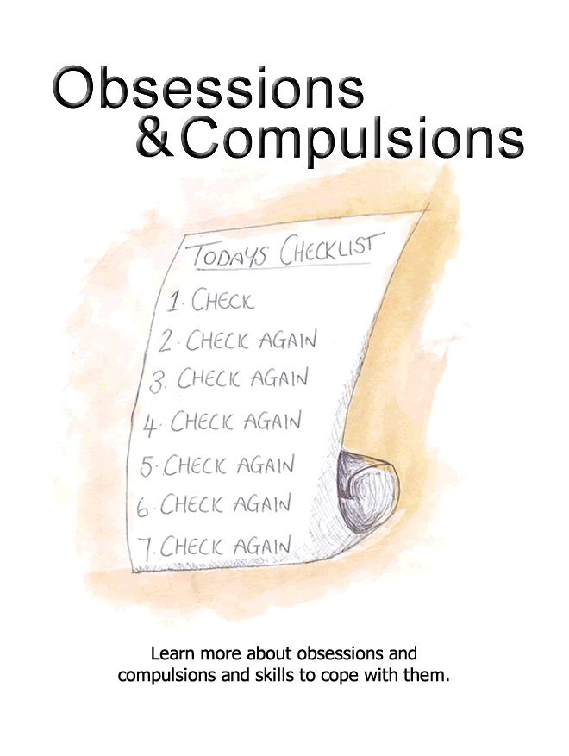
Self Help for Obsessions and Compulsions
- Do you spend large periods of your day worrying that you have forgotten to do something properly?
- Do you have an intense fear of germs or contamination?
- Do you spend large parts of your day cleaning or checking that you have performed certain tasks correctly (e.g. locking the door, turning off the cooker, etc)?
- Do you feel distressed if household items are not in their 'proper place'?
- Do you regularly experience distressing thoughts or images that are very difficult to get out of your mind?
- Do you feel pressure to perform certain rituals to avoid the possibility of negative events occurring?
- Do you worry that you will be held responsible for a negative event and go to extreme lengths to avoid this (e.g. check things over and over, perform superstitious rituals)?
If the answer to any of these questions is 'yes,' you may be experiencing obsessions and compulsions and you may find this workbook helpful.
This workbook aims to help you to:
- Recognise whether you may be experiencing obsessions and compulsions.
- Understand what obsessions and compulsions are, what causes them and what keeps them going.
- Find ways to reduce obsessions and compulsions.
Am I experiencing obsessions and compulsions?
If you experience obsessions and compulsions, it is likely that you will recognise some of the symptoms described below.
Please tick the boxes which regularly apply to you.
Feelings
Anxious / panicky
Frustrated / uneasy
Contaminated / unclean / dirty
Guilty / ashamed / disgusted
Under pressure / responsible
Physical Symptoms
Butterflies in your stomach / nauseous
Heart races / mind races
Dizzy / light headed
Tense body / muscular pain
Thoughts
I'm dirty / contaminated
I'm going to become ill / cause others to become ill
I could get burgled
What if I've left the cooker / iron / radio on?
It'll be my fault if I don't do something (to avert danger)
I'm a terrible person to think this way
I won't be able to cope unless I get this place straightened out
Behaviour Patterns
Check over and over that you have completed a task properly
Avoid leaving the house last so you don't have to lock up
Ask others to check you have turned all the appliances off properly
Repeatedly shower or wash your hands
Avoid touching objects that make you feel dirty
Say silent prayers in attempt to avoid disasters
Make sure everything is in its correct position
You try to push distressing thoughts and images from your mind
If you have ticked a number of the 'thoughts' or 'behaviours' boxes you may be experiencing obsessions and compulsions. However don't be alarmed, this is very common and there are things you can do to help. You will find some useful strategies in this workbook.
What are obsessions and compulsions?
Many people have habits and superstitions that they perform to avoid misfortune. For example, people often avoid walking under ladders or 'touch wood' to fend off bad luck. Obsessions and compulsions are essentially a more extreme form of this. It is when people begin spending large periods of time every day performing behaviours aimed at minimising danger, that they are described as experiencing obsessions and compulsions.
Obsession is the word used to describe when someone experiences unwanted thoughts, impulses, or images that are difficult to control. Common obsessions are about:
- Forgetting to do something (e.g. locking the door or turning off the cooker)
- Being contaminated by germs
- Harming others (e.g. knocking someone over in the car or harming someone with a knife)
- Performing socially unacceptable behaviours (e.g. swearing in church)
- A need for orderliness (e.g. everything must be in its correct place).
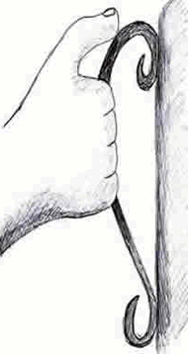
These obsessions are naturally anxiety provoking and are often followed by time consuming rituals which attempt to neutralise the discomfort they cause. Rituals which are performed to provide relief from the distress caused by obsessions are sometimes referred to as compulsions. Examples of compulsions include:
- Checking that you have performed tasks properly (e.g. locked the door)
- Putting things into their 'correct place'
- Washing yourself thoroughly
- Cleaning the house
- Counting items
People also often say silent prayers, picture happy images or repeat phrases over and over in their mind in order to minimise danger. Obsessions and compulsions usually occur together but they sometimes occur individually.
What causes obsessions and compulsions?
Thinking Styles:
Some people may have a thinking style that lends itself to developing obsessions and compulsions. For example, people who develop obsessions and compulsions appear more likely to overestimate the chances of something bad happening (e.g. their house being burgled). As such, they go to great lengths to avoid the possibility of this (e.g. check their door is locked a dozen times). It is also believed that people who develop obsessions and compulsions are more likely to believe that they will be held responsible and blamed if something negative does happen. This too makes them want to engage in rituals to bring relief from this fear. We also know that everyone has unwanted and unusual thoughts at times. However, people who develop obsessions and compulsions tend to view their unwanted thoughts as highly significant. For example, they may believe that having an unusual thought (e.g. of harming someone) makes it more likely that they will follow through with it, as opposed to seeing it as a random thought without meaning. People also sometimes believe that having an unpleasant thought (e.g. swearing in church) is just as bad as actually doing it. Similarly, people often worry that that having unpleasant thoughts is a sign that they are unusual or that something is wrong with them. As a result of these interpretations, people can feel distressed, frightened, guilty or ashamed about their thoughts. This is why they often engage in rituals to try and reduce some of these difficult emotions.
Life Events:
Obsessions and compulsions commonly develop following a period of stress in someone's life (e.g. a bereavement, financial problems or work place stress). Someone's experiences throughout life can also have an impact. For example, if someone has grown up in a household where cleanliness was a high priority, they may develop a sensitivity towards hygiene issues themselves. If this is the case, they may be more likely to engage in time consuming rituals to make themselves and their surroundings feel clean.
Biological Reasons:
There is also some evidence that biological factors play a small role in the development of obsessions and compulsions. For example, if someone in your immediate family has experienced obsessions and compulsions, there is a higher, albeit small chance, that you may go on to experience them too.
In reality, it is possible that a combination of these factors play a role in the development of obsessions and compulsions. However, in some ways it is less important to know what causes them, and more important to know what stops us overcoming them.
What keeps our obsessions and compulsions going?
Relief Seeking Rituals:
Those who experience obsessions and compulsions become distressed when they have an unwanted thought (e.g. I'm contaminated and will spread germs). In attempt to neutralise this, they engage in rituals designed to bring relief from this distress (e.g. wash their hands). Although this is a very understandable way of coping with an unwanted thought, it is actually one of the main reasons that people find it hard to overcome them.
This is because, although rituals help people to feel better at first (e.g. checking the door is locked), this relief is normally short lived and the unwanted thought soon returns (e.g. did I check it properly). Because of this, people soon perform their relief seeking ritual again, as it is the only way that they know how to gain relief from their distress. Unfortunately this creates a pattern of behaviour where people repeatedly engage in rituals in the search for relief, to the point that the rituals themselves become very time consuming and distressing.
Furthermore, people sometimes believe that the only reason their fears have not come true (e.g. that they will become ill after touching a door handle) is because they have been consistently performing their rituals (e.g. thoroughly washing their hands afterwards). Because of this, they feel it is necessary to continue. However, by doing so, they do not give themselves the opportunity to learn that they would be highly unlikely to become ill, even if they had not bothered to wash their hands.
Avoidance:
Another factor that keeps people's obsessions and compulsions going is their tendency to avoid doing things that normally trigger unwanted thoughts. For example, someone may avoid going to church due to their fear of committing blasphemy. However by avoiding church, they don't give themselves the chance to prove that they would have behaved perfectly had they gone, and as a result their fear remains.
Similarly, someone may never take a turn of cooking in case they leave the hob on and cause a fire. This precaution would likely leave them thinking �if I had cooked, I could've caused a terrible fire� and again their fear remains intact.
Blocking Out Thoughts:
Just as people avoid situations and tasks that trigger unwanted thoughts (e.g. cooking or being the last person to leave the house), they also try to avoid their unwanted thoughts by pushing them to the back of their minds. For example, someone who has a thought that they might harm their loved one will try to block this from their mind as best as they can. Unfortunately we know that the harder someone tries not to think about something, the more likely they are to do so. As a result, this coping strategy actually just ensures that the problem continues.
Unhelpful Thoughts:
People's thinking styles play a role in keeping their obsessions and compulsions going. For example, people often overestimate the likelihood of a negative event occurring if they did not perform their rituals (e.g. had I not checked every plug in the house was off 3 times, I could've burned the house down). Because of this they find it difficult to refrain from engaging in time consuming rituals. Their fear of being held responsible for negative events like this has the same impact.
It is likely that a combination of all these factors play a role in keeping obsessions and compulsions going. See below for an illustration of how these factors can interact and make it difficult for us to overcome their obsessions and compulsions.
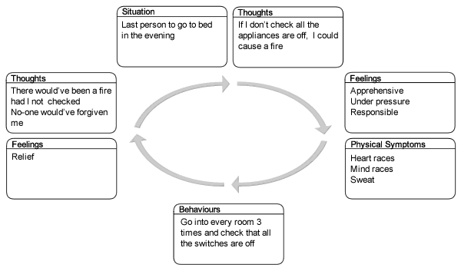
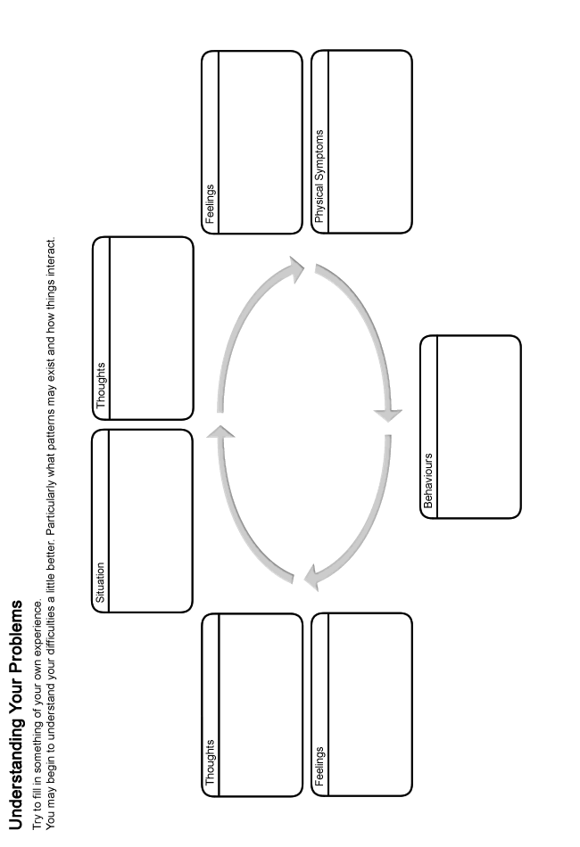
How can I overcome my obsessions and compulsions?
Fortunately, there are a number of strategies that we can use to reduce our obsessions and compulsions. These include:
- Learning how to gradually confront our unwanted thoughts (obsessions) without relying on relief seeking rituals.
- Tips to help us reduce our relief seeking rituals (compulsions).
- Learning how to challenge our unhelpful thoughts and see things in a more realistic light.
When going through this booklet it can sometimes be more helpful to try out the ideas above one at a time, rather than trying to learn them all at once. However simply take things at your own pace.
Gradually confronting your unwanted thoughts
People who experience unwanted thoughts (e.g. I've left the iron on) tend to engage in rituals (e.g. go home and check that it is switched off) to bring relief from the anxiety this causes. Although these rituals tend to reduce distress initially, they are actually unhelpful in the longer term. This is because people come to rely on performing rituals, as it is the only way they know how to gain comfort from their unwanted thoughts. This creates a pattern of behaviour where people feel compelled to repeatedly complete rituals in search of further relief. Soon this pattern can become very time consuming and debilitating.
Because of this, the best approach to overcome obsessions and compulsions is to gradually confront our unwanted thoughts without engaging in relief seeking rituals. For example, being the last person to leave the house and having to lock up would allow someone to confront their fear of burglary. By ensuring they do not repeatedly check the door is locked, they would be avoiding completing their relief seeking ritual.
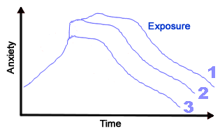
Of course, the thought of this may sound daunting, as we are likely to feel anxious when we stop ourselves from completing our relief seeking rituals. However research shows that if we can stay in a situation that we feel anxious in for long enough (without completing a relief seeking ritual), gradually our anxiety will reduce naturally. It is almost as though our body and mind become 'used to' the situation and our anxiety begins to fall. This may take around 30 minutes or more, but often happens more quickly. More importantly, if we subsequently do the same thing again in the future, the amount of anxiety we experience is likely to be less and less on each occasion. Not only this, but it is likely to pass more quickly each time too, until the point that we can do so without feeling high levels of anxiety. This strategy also allows people to build up evidence that it is unnecessary to perform a ritual to avoid disaster and their confidence can grow. For example:
Someone who felt contaminated if they didn't wash their hands after touching a public door handle.
- They set themselves the task of touching a public door handle, their anxiety began to rise.
- Resisting the urge to wash their hands, their anxiety eventually began to reduce.
- They then repeated that task everyday that week. Their anxiety got less and less and passed more quickly too.
- Their confidence increased each time, as they built up more and more evidence that they would not catch germs and become ill when they didn't wash their hands.
- Soon they were able to complete this task without feeling any anxiety.
Having said this, confronting your unwanted thoughts without engaging in relief seeking rituals can still be a daunting thought. The 5 steps described next can help to make this more manageable by breaking it down into gradual steps.
Step 1: Generating ideas for your exposure hierarchy
As tackling your obsessions and compulsions in this way can be a daunting thought, it can be helpful to do so gradually. Creating an exposure hierarchy can help you to do this. An exposure hierarchy is basically a list of all the situations surrounding your obsessions and compulsions that cause you varying degrees of anxiety (see the example below). The idea is that you confront the easiest (or least anxiety provoking) item on your hierarchy to begin with (whilst removing your relief seeking rituals) and work your way through to more difficult items as your confidence grows.
Example exposure hierarchy:
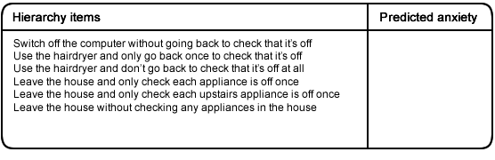
Use box 1 on page 14 to list items for your hierarchy. Don't worry about ranking the order of your items at this stage. To help you get ideas for your hierarchy, it may help to consider all the thoughts, images and situations that:
- Make you anxious (using the iron; using a knife to chop vegetables in front of someone; having items out of place; locking the door; preparing food)
- You avoid (e.g. leaving the house last; using a public bathroom; using the cooker)
- Make you want to perform a relief seeking ritual (e.g. seeing an item 'out of place'; touching certain objects)
It is important to try to ensure that the items on your list cause you varying degrees of anxiety (e.g. is not double checking the radio is switched off easier than not checking that the iron is switched off). This will allow you to work on overcoming your fear towards 'easier' items on your hierarchy to begin with.
Note: Often people find that they are troubled by obsessions and compulsions in more than one area (e.g. they worry about catching germs and about causing a fire). If this is the case you have two options. You can either create two different hierarchies to work on one at a time, or you can amalgamate them into one hierarchy using the exact same principles outlined in this section. For example, here is an exposure hierarchy for someone who is anxious about both unwanted thoughts about harming a loved one (e.g. a child), and being unable to cope with objects not in their 'right place'.
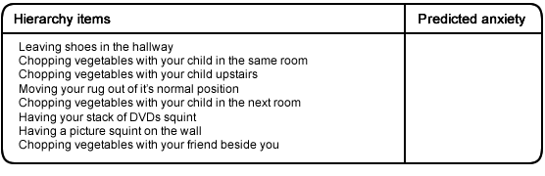
Step 2: Ranking the items on your hierarchy
Once you have a list of items for your hierarchy, the next stage involves trying to rank them in order of least anxiety provoking to most anxiety provoking. To help, try to predict how anxious you believe each item would make you feel on a scale from 0 to 100, where 100 is the most anxious you have ever felt and 0 is the most relaxed you have ever felt (use box 2 on page 14). Once you have completed this, simply rearrange the items on your list from least anxiety provoking to most anxiety provoking (use box 3 on page 14). For example:
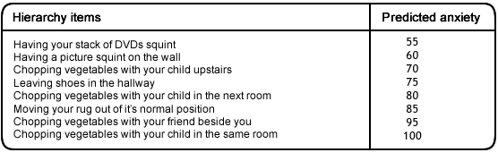
Step 3: Confronting the first item on your hierarchy
Once you have finalised your hierarchy, the next step is to confront the first item on it as soon as possible (this is often referred to as an exposure task). This should be the item that you predict will cause you the least amount of anxiety from your list. It is very important that when you do this, you do not perform any relief seeking rituals that you have used in the past. During exposure tasks it is important to:
- Avoid using any relief seeking rituals as they simply slow down your progress. See section 2 'Reducing relief seeking rituals' for further advice on this.
- Remember that although your anxiety will initially rise during an exposure task, it will fall if you remain in the situation for long enough.
- Be aware that anxiety is a natural and healthy reaction that everyone experiences. Although it can feel unpleasant, it is not dangerous and will gradually pass if you remain in the situation for long enough.
- Try to remain in the situation until your anxiety reduces by at least half.
- Focus on removing one ritual at a time (e.g. if your exposure task is to avoid double checking that the TV is off, still allow yourself to double check that the hairdryer is off). This can help stop you from taking on too much at once.
Step 4: Repeating the exposure exercise
Once you have completed your exposure task once, the next step is to do so again, over and over, as often as possible, until you have overcome your anxiety towards that item. You should find that each time you confront the item on your hierarchy, it will become slightly easier. As a rule of thumb, try to ensure that you engage in your exposure task everyday if you can. Remember that the more often you expose yourself to an item on your hierarchy, the quicker you will overcome your fear towards it.
Step 5: Moving onto the next item on your hierarchy
Once you have overcome your fear towards the first item on your hierarchy, you should follow the same steps with the next item on your hierarchy. Continue through your hierarchy in this manner until you have reached the top and you are less troubled by your obsessions and compulsions. Try to make sure that when you move onto each new item on your hierarchy, you keep up the progress that you have already made on other items and don't slip back into old habits.
Remember that as you progress through each stage of your hierarchy your confidence will grow. This should mean that items which are higher on your hierarchy - that seemed very daunting at first - will be less frightening when you actually come to face them because of your previous achievements.
Trouble shooting:
- If you attempt an exposure task and it does not go as well as you had hoped - try not to worry as this can happen from time to time. Try again as soon as you can.
- If the exposure task still seems too hard, see if you build in an extra step or two before it on your hierarchy. This will allow your confidence to grow further before facing it. For example:
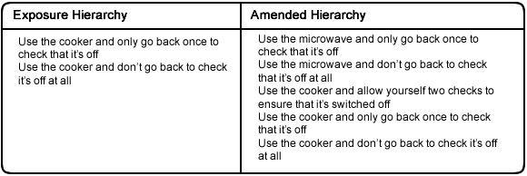
- If you find that your anxiety is not reducing during an exposure task - ask yourself:
  - Have you replaced your usual relief seeking ritual with another as this would normally stop you from progressing?
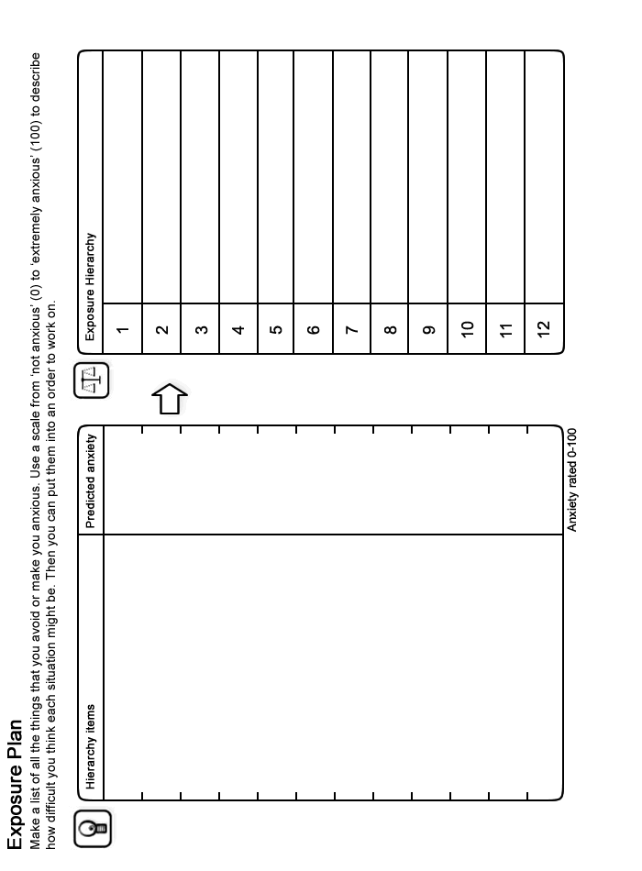
Reducing relief seeking rituals
It is very important to break the cycle of performing relief seeking rituals which are also known as compulsions. For example:
- Not washing your hands when you feel contaminated
- Not checking that an electrical socket has been switched off correctly
- Not picturing your loved ones alive and well to ensure that they remain safe
- Not triple checking that you have locked your car properly
By removing these rituals, you will give yourself the chance to prove that you do not have to complete them to avoid disaster. You will also be giving yourself the chance to experience anxiety, which will become less and less each time you complete an exposure task. Here are some tips to help with this:
- Try not to cut down on your relief seeking rituals by avoiding activities that trigger your urge to do them (e.g. don't avoid being the last person to leave home so you won't have to lock up; don't avoid knifes because it brings images into your mind of harming someone). This avoidance takes away your chance to work towards overcoming your obsessions and compulsions.
- Try not to rely on friends or family to help you out by completing rituals for you (e.g. don't ask them to check that all the plugs are off; don't ask them to clean for you; don't ask for reassurance that the door is locked). This would simply be replacing your relief seeking ritual and prevent you from facing your fear.
- If you find it very difficult to remove a relief seeking ritual, try to gradually reduce the amount of time you spend carrying it out (e.g. wash your hands more quickly; just have a very quick glance to check that plugs are switched off) until you have reduced it to a level you are satisfied with.
- Similarly, if you typically check items a certain number of times before you feel comfortable - try to gradually cut this down. You can even build this into your hierarchy (e.g. Step one � leave home and allow yourself two checks to ensure that the door is locked. Step two � leave home and only allow yourself to check that the door is locked once).
- Another idea if you are struggling is to try to delay the completion of a relief seeking ritual (e.g. by 5 minutes). Begin to increase this time gradually until you no longer feel the need to carry out your ritual at all.
- Spend time thinking about if you complete other less obvious rituals during exposure tasks. If you notice any, it is important to remove these as well. For example, if it is your normal practice to touch every light switch to check that it is in the 'off' position, make sure you don't replace this with visually checking that it is off. In other words, try to remove all behaviours intended to bring you relief.
- Focus on removing one ritual at a time (e.g. if your exposure task is to avoid double checking that the TV is off, still allow yourself to double check that the hairdryer is off). This can help stop you from taking on too much at once.
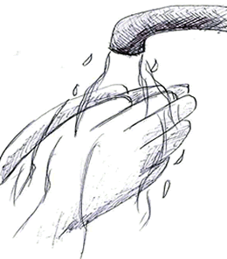
As we know, a compulsion is anything that brings relief from an obsession. It is perhaps most common for the compulsions people use to be physical behaviours (e.g. returning home to check that the door is locked properly; washing their hands to avoid the risk of contamination).
However, sometimes people's compulsions are thoughts rather than behaviours. For example, they may picture their family as healthy and happy to bring relief from an image that they have come to harm. Despite the different forms of compulsions, the idea that we should stop ourselves doing them is exactly the same (e.g. resisting picturing your family is healthy).
Another common way people try to cope with obsessions and compulsions of this nature is to try and block the obsessions from coming into their mind in the first place. In addition, they also try to 'push away' any obsessions that they do experience. Although this is an understandable way to try and cope, it often makes the problem worse. This is because the harder we try not to think about something - the more and more it comes back into our mind. Basically, the harder we try not to think of something, the more likely we are to do so. You can test this theory out for yourself. Try, for example, not to think about pink elephants for the next 30 seconds. You will likely find this very difficult.
Because pushing thoughts away actually makes the problem worse, we should try to resist doing this. Instead, remind yourself that the thoughts are nothing to be anxious about as they are meaningless and random. Try not to attach any importance to them whatsoever. Take the attitude that you don't care if these thoughts enter your mind as they are so unimportant anyway. You should find that the less significance you attach to these thoughts, the quicker they will drift out of your mind.
Challenging Unhelpful Thoughts
The way people think has an impact on their obsessions and compulsions. More specifically, certain thoughts make it harder for people to resist completing relief seeking rituals. It is therefore important to remember that our thoughts are not always accurate. Indeed, most of our unhelpful thoughts occur automatically, outside of our control and do not have any real basis. As such we should question them, as more often or not they are wrong assumptions.
The following section will help you to begin recognising if you are thinking about things in an unhelpful or unrealistic way and discuss how you can begin to change this. By doing so, you can learn to see things in a more realistic light which can help to reduce your obsessions and compulsions.
We know that often people's unhelpful thoughts follow similar patterns (see overleaf). Being aware of these can make it easier to identify the unhelpful thoughts that often make it more difficult to resist completing relief seeking rituals.
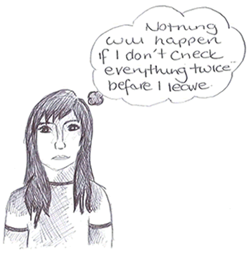
Patterns of unhelpful thoughts
The first step you need to take before challenging your unhelpful thoughts is to recognise when they are happening. Being aware of the common patterns that unhelpful thoughts often follow, can assist you to recognise when you have them. See below for some of the common patterns that our unhelpful thoughts follow:
Exaggerated feelings of responsibility
People who experience obsessions and compulsions are often particularly anxious about being held responsible and blamed if something bad occurs. For example:
- They worry about other people's reactions if there was a fire because they left a plug on or if someone became unwell after eating food they prepared.
Overestimating the
possibility of danger
It is also common for people who experience obsessions and compulsions to overestimate the danger involved in certain situations. For example:
- They believe that they would almost definitely be burgled if they forget to lock their door.
Underestimating their ability to cope with anxiety
People who believe that anxiety is dangerous and that they cannot tolerate it typically find it more difficult to resist completing relief seeking rituals. For example:
- They may have the belief that too much anxiety will make them go mad.
- Worrying that their anxiety will 'get out of control' if they do not do something to reduce it.
Difficulty tolerating uncertainty
Sometimes people who experience obsessions and compulsions find it very difficult to tolerate uncertainty. For example:
- They insist on being 100% sure that a task has been completed perfectly.
With such high standards, they are inclined to go to extra lengths to ensure that everything has been completed properly. For example:
- I must know for sure that my taps are off or I'm reckless.
Attaching high significance
to thoughts
When people attach a high level of significance to their thoughts, they are more likely to engage in relief seeking rituals: For example:
- Someone believing that a random image of them swearing in church is just as bad as following through with it.
- Believing that their intrusive thought (e.g. about harming someone they love) means that they must be an evil person.
Other people sometimes worry that by thinking about something negative, it is more likely to happen (e.g. a loved one being involved in a car accident). Unfortunately, placing such high significance on thoughts encourages people to complete rituals to counteract them.
Do any of your unhelpful thoughts follow some of these patterns? Jot down any examples you can think of into the box below:
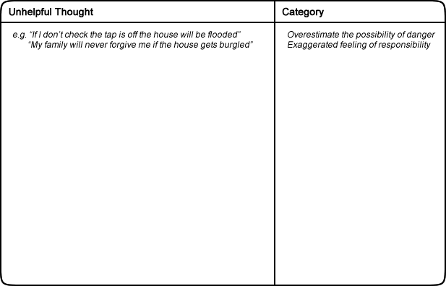
The next part of this workbook discusses how you can go about challenging your unhelpful thoughts and begin to see things in a more realistic light. This may reduce your tendency to engage in relief seeking rituals.
How to challenge unhelpful thoughts
Once you have recognised an unhelpful thought the next stage is to challenge it. To do this, you can ask yourself a serious of questions. See the example below:
Situation: You are about to chop vegetables with your son in the house.
An image of harming him with the knife comes into your mind.
How you feel: Disgusted, terrified.
Unhelpful thought: I'm a terrible father for having this thought.
I should be in prison! I must put this right!
Challenges to an unhelpful thought
Now you can challenge your unhelpful thoughts by asking these questions.
Is there any evidence that contradicts this thought?
- I love my son very much.
- I always go out of my way to protect him.
- I didn't choose to have this thought.
Would you apply the same standard to other people in your shoes?
- If it was my brother who had this thought about my nephew, I wouldn't think he should be in jail.
Can you remember any times where you have not performed a compulsion, if so, what happened?
- Once the phone rang and distracted me before I got a chance to 'put things right'. In the end nothing bad happened.
What new knowledge do you have now that could help in this situation?
- I know that having a thought is a lot different from actually following through with. it
What are the costs and benefits of thinking in this way?
- Costs: I feel miserable. It makes me feel like I shouldn't spend anytime with him.
- Benefits: I can't think of any.
Once you have asked yourself these questions, you should read through your answers. Try to come up with a more balanced or rational view. For example:
Everyone has unusual thoughts at times; they don't reflect how I feel about my son. Having a thought about something does not mean that I want to follow through with it.
Try to apply these questions to the unhelpful thoughts that you notice. It can help to reduce your relief seeking rituals. You can use this technique to test your thoughts are realistic and balanced.
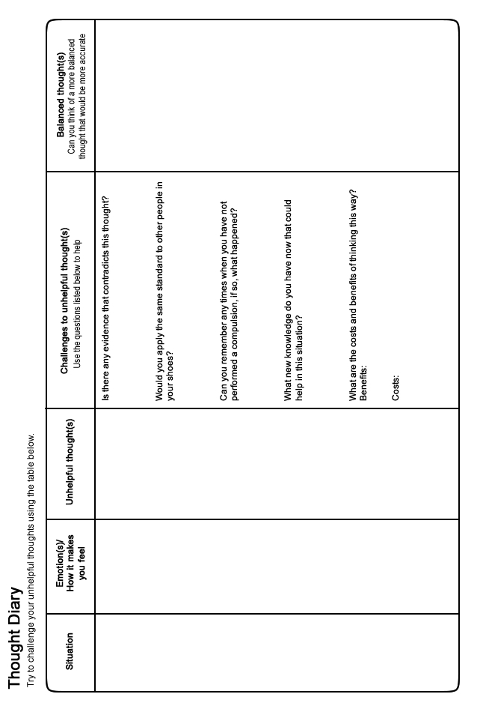
Final Word
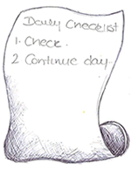
We hope that you found some of the ideas in this booklet useful. You can continue to use the techniques you found helpful long into the future and they should continue to benefit you. If some of the ideas are not particularly helpful at first, it is perhaps worth sticking with them for a few weeks to give them a chance to work. If however you feel your situation remains largely unchanged or if you did not find this booklet useful, you should speak to your GP who can tell you about the other options available which you could find helpful.
Further Information and Resources
For further information and self-help resources go to Moodjuice online:
http://www.moodjuice.scot.nhs.uk
Moodjuice is a website designed to offer information and advice to those experiencing troublesome thoughts, feelings and behaviours. In the site you can explore various aspects of your life that may be causing you distress and obtain information that will allow you to help yourself. This includes details of organisations, services and other resources that can offer support. This self help guide comes from a series that you can access and print from Moodjuice. Other titles available include:
- Depression
- Anxiety
- Stress
- Panic
- Sleep Problems
- Bereavement
- Anger Problems
- Social Anxiety
- Phobias
- Traumatic Stress
- Obsessions and Compulsions
- Chronic Pain
Some Useful Organisations
The following organisations or services may be able to offer support, information and advice.
Samaritans
Samaritans provides confidential emotional support, 24 hours a day for people who are experiencing feelings of distress or despair, including those which may lead to suicide. You don't have to be suicidal to call us. We are here for you if you're worried about something, feel upset or confused, or you just want to talk to someone.
Phone:
116123

Web Site:
http://www.samaritans.org
Anxiety UK
National charity established in 1970 to provide support and services to those suffering from all anxiety disorders, obsessive compulsive disorder, generalised anxiety disorder, panic attacks, social phobia, simple phobia, phobia and tranquiliser issues.
Phone:
08444 775 774

Web Site:
http://www.anxietyuk.org.uk/
OCD Action
We provide support and information to anybody affected by Obsessive Compulsive Disorder (OCD), working to raise awareness of the disorder amongst the public and frontline healthcare workers, and striving to secure a better deal for people with OCD.
Phone:
0845 390 6232

Web Site:
http://www.ocdaction.org.uk
Breathing Space
Breathing Space is a free, confidential phone line you can call when you're feeling down. You might be worried about something - money, work, relationships, exams - or maybe you're just feeling fed up and can't put your finger on why.
Phone:
0800 83 85 87

Web Site:
http://www.breathingspacescotland.co.uk
Living Life to the Full
Living Life to the Full is an online life skills course made up of several different modules designed to help develop key skills and tackle some of the problems we all face from time to time.
Web Site:
http://www.llttf.com/
OCD UK
A provider of information, practical and emotional support for anyone affected by Obsessive Compulsive Disorder (OCD). We facilitate a safe environment for people who experience the condition to communicate with each other and provide mutual understanding and support.
Phone:
0845 120 3778

Web Site:
http://www.ocduk.org
Further Reading
The following books may be able to offer support, information and advice.
Getting Control: Overcoming Your Obsessions and Compulsions
This revised guide helps those who suffer from compulsions and obsessive behavior gauge the seriousness of their problem, control its symptoms, and reduce the anxieties that cause it.
Author: Lee Baer
Published: 2000
Living with Fear
This self-help guide gives practical advice to people who are suffering from phobias, panic, obsessions, rituals or traumatic distress. In this second edition the author has also included new phobias such as the fear of AIDs contamination as well as the latest treatments. The case examples in this edition are drawn from many parts of the world. References, examples and case studies are also provided.
Author: I M Marks
Published: 2005
Obsessive Compulsive Disorder - The Facts
This book explains and provides information on various aspects of obsessions and compulsions including the symptoms, treatments and the causes.
Author: Padmal de Silva & Stanley Rachman
Published: 2009
Overcoming Obsessive Compulsive Disorder
Are you plagued by a recurring thought or idea that just wont go away, feel the need to wash your hands repeatedly, to hoard things, or to repeatedly check that all appliances in the house have been turned off before you leave? These are just some of the common symptoms of obsessive compulsive disorder (or OCD), a condition that that causes distress to hundreds of thousands of people. Cognitive behavorial therapy has been clinically proven to significantly reduce these and other symptoms in the majority of cases. With this step by step approach you can learn how to break free from the destructive cycle of obsessive behavior and regain control of your life. This book shows you how to reduce the distress caused by disturbing thoughts, images and urges, helps you face fears and troubling situations, reduces and gradually helps you overcome compulsions, offers advice on how partners, relatives and friends can help.
Author: D Veale & R Wilson
Published: 2009
Stop Obsessing!: How to Overcome Your Obsessions and Compulsions
Drawing on clinical research, this updated handbook describes the symptoms of obsessive compulsive disorder, explains how it can be treated with behavior therapy, and includes advice on reducing stress.
Author: Edna Foa & Reid Wilson
Published: 2001
The Boy Who Couldnt Stop Washing.....
In this examination of obsessive compulsive behaviour case histories are described, often in the words of the afflicted, and the effectiveness of various treatments is discussed. This pathological state is now regarded as much more common than was thought earlier, with possibly a million cases in Britain. The boy who couldnt stop washing is only one case described. There is also the man who is convinced, every time he drives his car, that he has run someone over and turns back again and again to check the roadside for a body, the woman who, in an effort to ensure her eyebrows are symmetrical, finally plucks out every hair, a man who cannot enter his front door without completing an elaborate ritual, another who checks his stove hundreds of times a day to make sure he really turned off the gas.
Author: J Rapport
Published: 1990
The OCD Workbook
Your guide to breaking free from Obsessive Compulsive Disorder
Author: B Hyman & C Pedrick
Published: 2010
Understanding Obsessions and Compulsions (Overcoming Common Problems)
This book provides a comprehensive guide to self-help, explaining the principles of anxiety reduction, giving treatment instructions in easy-to-understand language. It covers compulsive checking, washing, hoarding, obsessional thoughts and worry, obsessional personality and depression.
Author: Frank Tallis
Published: 1992

